Lab Worksheet 02

Q01:
a. Math.sqrt(B * B + 4 * A * C);
b. Math.sqrt(X + 4 * Math.pow(Y , 3));
c. Math.cbrt(X * Y);
d. Math.PI * r * r

Q02:
package Q02;
import java.util.Scanner;
public class Q02 {
public static void main(String[] args){
Scanner input = new Scanner(System.in);
System.out.print("Enter Length in Centimeter: ");
double number = input.nextDouble();
double totalinches = number / 2.54;
int feet =(int)totalinches / 12;
double inches = totalinches % 12;
System.out.printf(" %.2f cm = %d ft %.2f inches",number,feet,inches);
input.close();
}
}

Output:
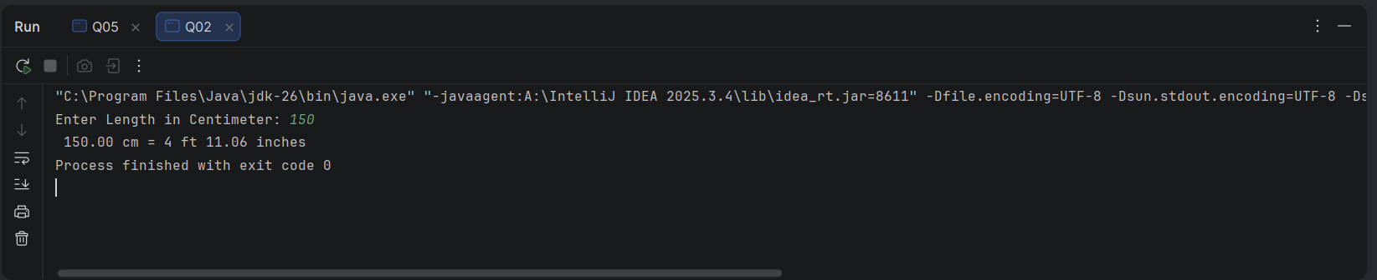

Q03:
package Q03;
import java.util.Scanner;
public class Q03 {
public static void main(String[] args){
Scanner input = new Scanner(System.in);
System.out.print("Enter temp in celsius - ");
double temp_in_celsius = input.nextDouble();
double Fahrenheit = (temp_in_celsius * 1.8) + 32;
System.out.printf("%.2f °C = %.2f °F",temp_in_celsius,Fahrenheit);
input.close();
}
}

Output:
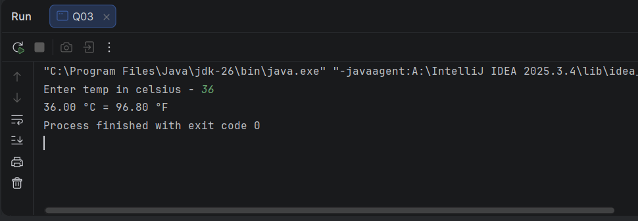
Q04
package Q04;
import java.util.Scanner;
public class Q04 {
public static void main(String[] args){
Scanner input = new Scanner(System.in);
System.out.print("Enter your weight in lbs: ");
double weight = input.nextDouble();
double calories = weight * 19;
System.out.printf("Total calories you need - %.3f" , calories);
input.close();
}
}

Output
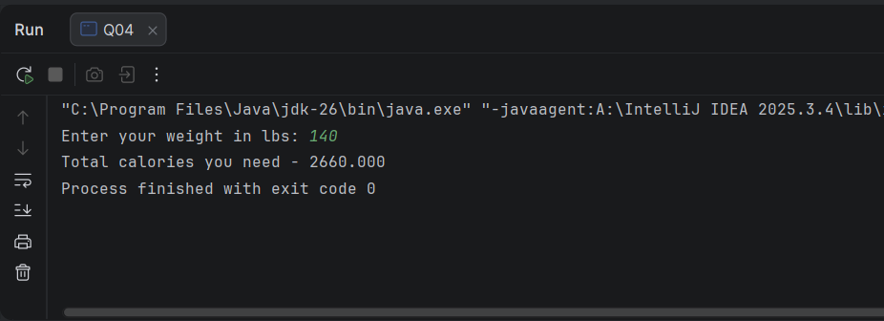
package Q05;
import java.util.Scanner;
public class Q05 {
public static void main(String[] args){
Scanner input = new Scanner(System.in);
System.out.print("Enter temp in fahrenheit: ");
double temp_in_fahrenheit = input.nextDouble();
double celsius = (5.0/9.0) * (temp_in_fahrenheit - 32);
System.out.printf("%.2f °F = %.2f °C",temp_in_fahrenheit,celsius);
input.close();
}
}

Q05

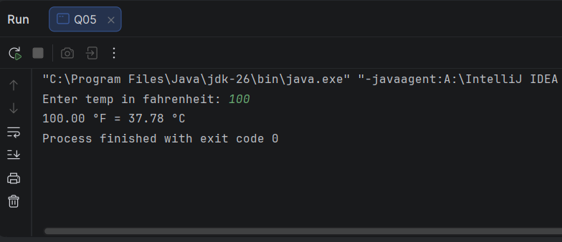
package Q06;
import java.time.LocalDate;
import java.util.Scanner;
public class Q06 {
public static void main(String[] args){
Scanner input = new Scanner(System.in);
System.out.print("Enter your birth year: ");
int birth_year = input.nextInt();
int l_date = java.time.Year.now().getValue();
int age = l_date - birth_year;
System.out.printf("Your age is %d",age);
input.close();
}
}

Q06
Output:
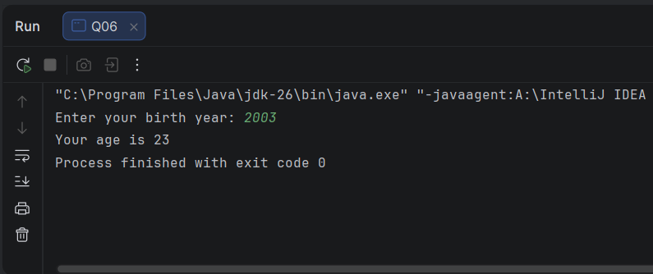
Output:
package Q07;
import java.util.Scanner;
public class Q07 {
public static void main(String[] args){
Scanner input = new Scanner(System.in);
System.out.print("Enter ur weight here: ");
double weight = input.nextDouble();
System.out.print("Enter ur height here: ");
double height = input.nextDouble();
double BMI = weight / Math.pow((height /100),2);
System.out.printf("Your Calculated BMI is %.3f",BMI);
input.close();
}
}
Q07
Output:
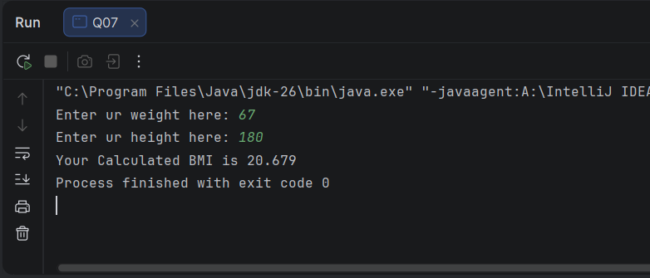
package Q08;
import java.util.Scanner;
public class Q08 {
public static void main(String[] args){
Scanner input = new Scanner(System.in);
System.out.print("Enter radius here: ");
double r = input.nextDouble();
double v = (4.0/3.0) * (Math.PI * Math.pow(r,3));
System.out.printf("Sphere Volume - %.3f ",v);
input.close();
}
}

Q08
Output:
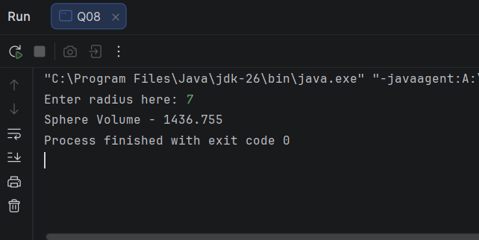

Q09
package Q09;
import java.util.Scanner;
public class Q09 {
public static void main(String[] args){
Scanner input = new Scanner(System.in);
System.out.print("Enter principle amount($): ");
double p = input.nextDouble();
System.out.print("Annual interest rate (in percent): ");
double r = input.nextDouble();
System.out.print("Number of years: ");
int n = input.nextInt();
double Amount = p * Math.pow( (1 +(r/100)) , n);
System.out.printf("Your earned $%.2f after %d years", Amount,n);
}
}

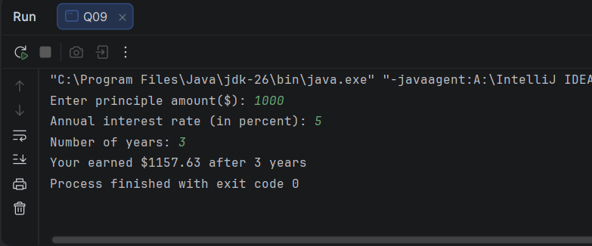
Output:

package Q10;
import java.util.Scanner;
public class Q10 {
public static void main(String[] args){
Scanner input = new Scanner(System.in);
System.out.print("Enter loan amount($): ");
double loan_a = input.nextDouble();
System.out.print("Annuel interest rate(%): ");
double a_interest_rate = input.nextDouble();
System.out.print("Loan period(In Years): ");
int loan_p = input.nextInt();
double monthly_interest_rate = a_interest_rate / 100.0 / 12;
int number_of_payments = loan_p * 12;
double monthly_payment = (loan_a * monthly_interest_rate) / (1- Math.pow(1 / (1 + monthly_interest_rate),number_of_payments));
double total_payment = monthly_payment * number_of_payments;
System.out.printf("Monthly payment is $%.2f and Total payment is $%.2f",monthly_payment,total_payment);
}
}

Q10

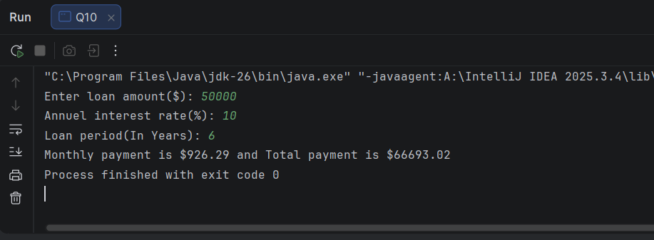
Output:

